1. Region and Domain State the region and the domain category that your data sets are about.

Dayton, Ohio, United States

Economic activity or measures

1. Research Question You must state a question about the domain category and region that you identified as being interesting.

How hot is the real estate market in Dayton in comparison to some surrounding counties?

1. Links You must provide at least two links to publicly accessible datasets. These could be links to files such as CSV or Excel files, or links to websites which might have data in tabular form, such as Wikipedia pages.
   1. Dayton: <https://fred.stlouisfed.org/series/HORAMSA19380>
   2. Greene: <https://fred.stlouisfed.org/series/HORACOUNTY39057>
   3. Miami: <https://fred.stlouisfed.org/series/HORAMMCOUNTY39109>
   4. Montgomery: <https://fred.stlouisfed.org/series/HORAMMCOUNTY39113>
2. Image You must upload an image which addresses the research question you stated. In addition to addressing the question, this visual should follow Cairo’s principles of truthfulness, functionality, beauty, and insightfulness.

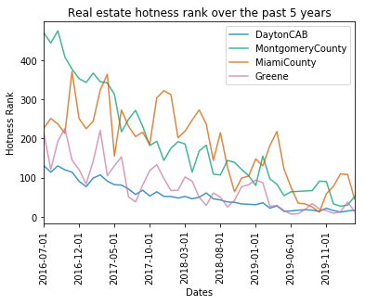

1. Discussion You must contribute a short (1-2 paragraph) written justification of how your visualization addresses your stated research question.

This visualization was concerned with answering the question of how lucrative is the Dayton real estate market in comparison to surrounding counties (Montgomery, Miami and Greene). The federal reserve website cites hosts data from realtor.com. Realtor.com ranks a real estate market on the basis of the demand and supply scores which are then combined into a hotness score and corresponding rank. The rank data was acquired and has been plotteed in this figure.

The plot indicates the trend from data every month between July 2016 and Mar 2020. It can be seen that the Dayton real estate rank has almost always been better than Montgomery county and Miami county. Greene counties real estate rank has been better in certain months but is very erratic over all. The Dayton real estate hotness rank has gradually improved and has been fairly stable so it can be inferred that it is better than the compared counties. Over all, the region seems to be improving since all counties have better ranks today than previous years.

Truthfulness: All data over a range of 5 years has been used instead of just for current year.

Functional: legends have been included to mark colors to county names

Beauty: The chart was kept clean and minimal with a line plot

Insightful: the hotness rank data was for Dayton was compared to four surrounding counties and it could readily be seen that it is better than the surrounding counties. Instead of demand scores, supply scores and/or hotness scores: rank was chosen instead